# EXCEL ASSIGNMENT

***Task 1: Cleaning the Dataset for Accurate Restaurant Listings***

* **Scenario: Zomato’s dataset contains duplicate entries and missing values. Learners will clean the data, ensuring all future analyses is based on reliable information.**
* **Steps: Remove duplicates, handle missing values, and ensure the dataset is prepared for further analysis.**
* **Deliverable: A clean dataset, free from duplicates and missing values, forming a reliable foundation for subsequent tasks.**

**Solution:**

* **Changed the datatypes of each column.**
* **Remove the duplicates in the following steps: Select the data🡪 Data tab🡪 Remove Duplicates**
* **To handle missing values below VBA code is written and apply using Macro.**

***Task 2: Categorizing Restaurants by Customer Ratings***

* **Scenario: Zomato wants to categorize restaurants based on customer ratings to identify top and underperforming venues.**
* **Steps: Categorize restaurants into rating groups (Excellent, Good, Average, Poor), and summarize performance by rating.**
* **Deliverable: A summary table categorizing restaurant performance based on customer ratings.**

**Solution:**

* **We can categorize the restaurant performance based on customer ratings using COUNTIF function. But as it’s already provided in the data, so created the below pivot table as a summary table.**
* **The table will showcase the number of restaurants under each category and average cost for two of each category.**

***Task 3: Verifying Service Availability in Specific Cities (VLOOKUP)***

* **Scenario: Customers search for specific services, such as table booking or online delivery. Zomato needs to verify which restaurants in each city offer these services.**
* **Steps: Use VLOOKUP to match restaurants offering specific services.**
* **Deliverable: A table summarizing service availability across cities, including table booking and online delivery services.**

**Solution:**

* **Making a summary table of city, restaurants, table booking and online delivery.**
* **City and Restaurant: Take the names from Cleaned data sheet.**
* **Table Booking:** **IF(ISERROR(VLOOKUP(B2,'Cleaned data’! $B$2:$U$9552,12,FALSE)),   
   "",VLOOKUP(B2,'Cleaned data'!$B$2:$U$9552,12,FALSE))**
* **Online Delivery:** **IF(ISERROR(VLOOKUP(B2,'Cleaned data’!$B$2:$U$9552,13,FALSE)),   
   "",VLOOKUP(B2,'Cleaned data'!$B$2:$U$9552,13,FALSE))**
* **Formula explains:**

**VLOOKUP Function: This function looks for a value in the first column of a specified range and returns a value from a specified column within that range.**   
 **Parameters:**

* **A3: This is the value being searched for.**
* **'Cleaned data’! $B$2:$U$9552 : This defines the range where the search will take place, specifically from column B to column U, covering rows 2 to 9552 on Sheet1.**
* **12/13: This indicates that the function should return a value from the 12th column of the specified range.**
* **FALSE: This means that the function is looking for an exact match of the value in A3.**

**ISERROR Function: This function checks if the VLOOKUP operation results in an error**

**IF Function: If VLOOKUP results in an error (i.e., the value is not found), it returns an empty string (""). If no error occurs, it returns the result from the VLOOKUP.**

* **For more interactive , taking the flag for both table booking and online delivery as if the table booking will be Yes we are taking 1 same for online delivery as well.**
* **Created a pivot table, City, Sum of table booking and online delivery to see services comparison across cities and created a chart for the visualisation.**

* **From this above chart, we can see the number of services available across cities and can compare them effectively to get insight which service is mostly available in the city.**

***Task 4: Cross-Referencing Country Codes for Restaurant Distribution (XLOOKUP)***

* **Scenario: As Zomato expands globally, learners will cross-reference country codes with country names to visualize geographic restaurant distribution.**
* **Steps: Use XLOOKUP to map country codes with country names.**
* **Deliverable: A dataset showing the country name corresponding to each restaurant.**

**Solution:**

* **Taking Restaurant Names and Country Code from Zomato data.**
* **Based on country code using XLOOKUP to get the country names from country data.**
* **XLOOKUP formula: XLOOKUP(B2,'[Country-Code.xlsx] 'Cleaned data'!$A$2:$A$16,**

**'[Country-Code.xlsx] 'Cleaned data'!$B$2:$B$16,"Not Found")**

* **Formula explains:**

**Search Value: This is the value we want to find. In this case, it refers to the value in cell B2.**

**Lookup Array : This is the range where XLOOKUP will search for the value from B2. Here, it’s looking in column A of the specified workbook and sheet.**

**Return Array :This is the range from which the function will return a value if it finds a match. It corresponds to column B of the specified workbook and sheet.**

**If Not Found :This argument specifies what to return if the value from B2 is not found in the lookup array. In this case, it will return the text "Not Found."**

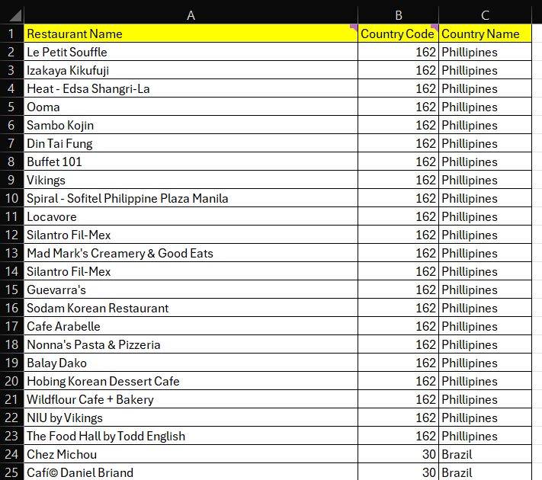

***Task 5: Analysing Customer Preferences by Cuisine (INDEX-MATCH)***

* **Scenario: Zomato wants to understand customer preferences by cuisine type, helping optimize restaurant recommendations.**
* **Steps: Use INDEX-MATCH to analyse and cross-reference customer preferences by cuisine across cities.**
* **Deliverable: A summary of customer preferences by cuisine and city.**

**Solution:**

* **Making a summary table by taking City, Cuisines and Customer rating.**
* **Based on city and cuisine getting Customer Rating by using INDEX-MTCH function.**
* **Index-Match formula:**

**INDEX(‘Cleaned data’!$R$2:$R$9552,MATCH(1,(‘Cleaned data’!$D$2:$D$9552='Customer Preference'!A2)*(‘Cleaned data’!$J$2:$J$9552='Customer Preference'!B2),0))**

* **Formula explains:**

**INDEX Function: The INDEX function returns a value from a specified range**

**based on a row number. Here, the range in index function is of average ratings and row number provided by match function.**

**MATCH Function: The MATCH function is used to find the position of a value within a specified range. In this case, it looks for the value 1 in the array created by the logical conditions.**

**Multiplication of Logical Arrays: When you multiply the two arrays of TRUE/FALSE values, TRUE is treated as 1 and FALSE as 0. This means that for any row where both conditions are TRUE (i.e., the city matches the one in A2 and the cuisine matches the one in B2), the product will be 1.**

**Finding Position of Match: This part of the formula searches for the value 1 in the resulting array from the multiplication. The 0 indicates that we want an exact match. The result will be the row number where both conditions are true.**

* **Based on the result making a Pivot table by taking City and cuisine as Rows and Average of Customer ratings as value.**
* **Based on the Pivot table making a chart (Present in Dashboard tab) and adding slicer, which will show for one city which cuisine is having how much rating and which is highly rated.**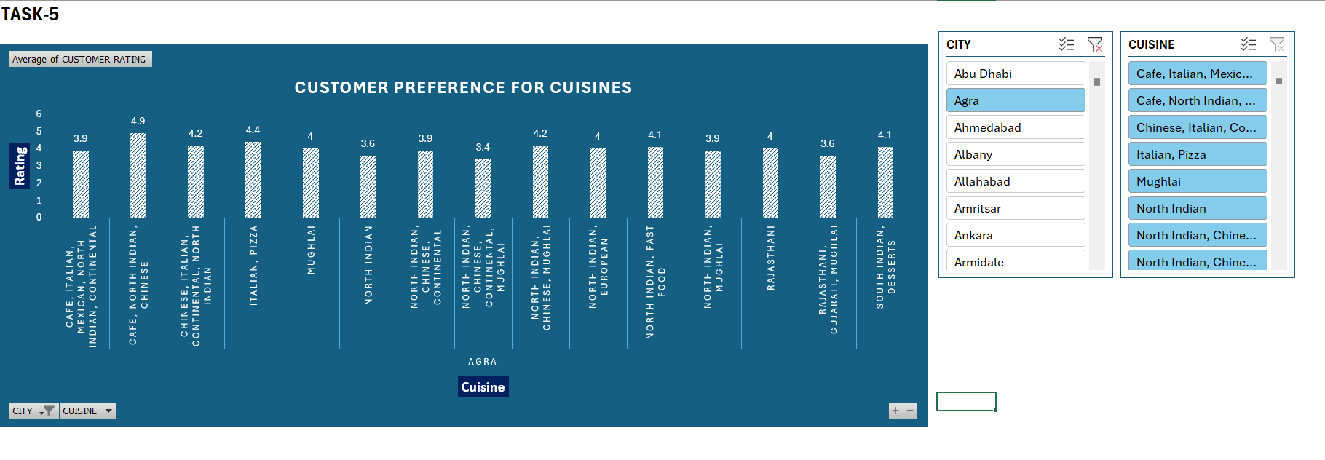

***Task 6: Price Range and Ratings Analysis (Pivot Tables)***

* **Scenario: Learners will analyse how restaurant price ranges affect customer satisfaction, providing insight into pricing strategy.**
* **Steps: Use Pivot Tables to compare ratings by price range, and visualize using Pivot Charts.**
* **Deliverable: A Pivot Table showing restaurant ratings by price range, with accompanying charts.**

**Solution:**

* **Making a pivot table by taking Price range as Rows and Customer rating average as Values.**
* **Making a pivot chart (present in Dashboard tab) for the visual representation of the relationship between price range and customer satisfaction.**

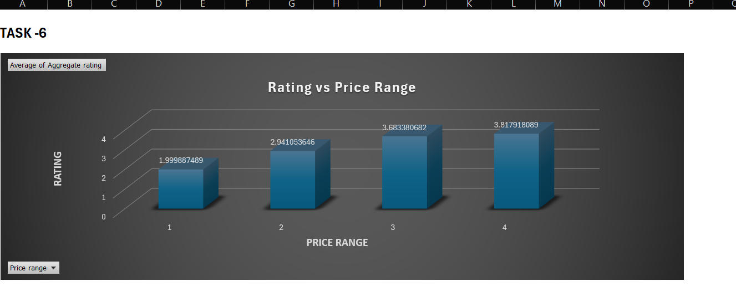

* **By the above chart, we can conclude that the restaurants with low end price range (1 as Low) have less customer satisfaction.**
* **Whereas, the restaurants with high end price range (4 as High) have more customer satisfaction.**
* **Hence, Customers are more satisfied with the high price range restaurants.**

***Task 7: Geographic Heatmap of Restaurant Density and Ratings***

* **Scenario: Zomato’s leadership team needs to understand how restaurant density and customer ratings are distributed geographically.**
* **Steps: Use geographic data to create a heatmap showing restaurant density and customer satisfaction by city.**
* **Deliverable: A geographic heatmap visualizing restaurant distribution and performance across cities.**

**Solution:**

* **While making a summary table by taking city and tried to project using Field Map it’s not working properly, so taking country to showcase the Geographic Heatmap.**
* **Took Country code, Country Name, Count of Restaurants and Customer rating average as columns.**
* **Country Code from Master Sheet Data.**
* **Country Name =** **XLOOKUP(A2,'[Country-Code.xlsx]Sheet1'!$A$2:$A$16,'[Country-  
   Code.xlsx]Sheet1'!$B$2:$B$16,"Not Found")**

**Here, taking the Country Code based on that lookup in Country Code workbook   
and return Country Name.**

* **Count of Restaurants = COUNTIF('Cleaned data’!C$2:C$9552,A2)**

**Here, taking Country Code as range and counting for a specific Code.**

* **Customer rating average = AVERAGEIF(Cleaned data'!C$2:C$9552,A2, Cleaned**

**data'!R$2:R$9552)**

**Here, taking Country Code as range and calculating average on Aggregate Rating   
column and taking it for a specific Code.**

* **From the above maps, we could be able to see the restaurants distribution across different countries.**
* **Also, could be able to see the average rating of customers across different countries which will showcase the performance of restaurants.**

***Task 8: Performance Comparison by Service Type (Online Delivery vs. Dine-In Only)***

* **Scenario: Zomato wants to compare the performance of restaurants offering online delivery with those offering dine-in only.**
* **Steps: Analyze ratings and votes for online delivery versus dine-in restaurants.**
* **Deliverable: A comparison of restaurant performance by service type, highlighting how online delivery affects customer engagement.**

**Solution:**

* **Made a summary table by taking Services, Count of Restaurants, Average Rating, Total Votes and Engagement Ratio.**
* **Count of Restaurants: Taking count of Restaurants where online delivery is available or not.**
* **Average Rating: Taking average of customer rating based on the service option, using AVERAGEIF.**
* **Total Votes: Taking total votes based on the service option, using SUMIF.**
* **Engagement Ratio: Getting it by dividing the total votes and count of Restaurants.**

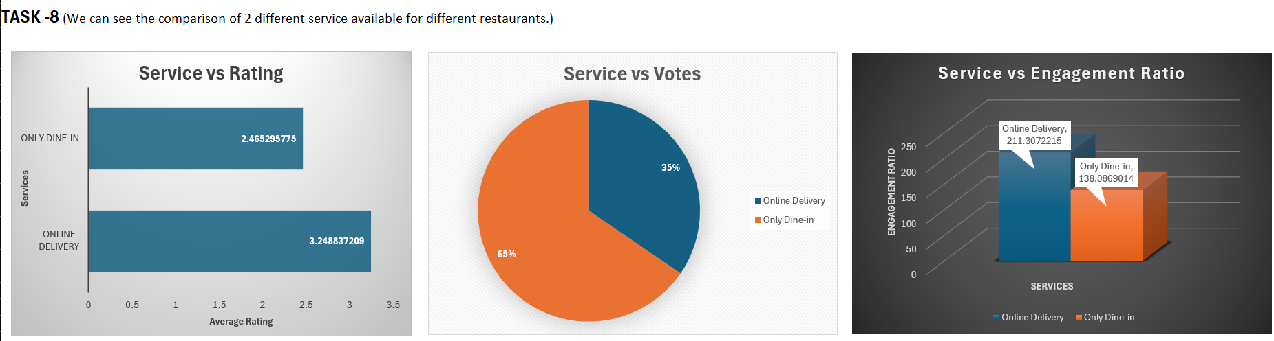

* **In the first chart, we are comparing the services based on average customer rating. We get an insight that Online Delivery is preferable by customers.**
* **In the Second chart, we are comparing the services based on total votes given. We get an insight that Dine-in option is getting more votes, means this service is more commonly available.**
* **In the Third chart, we are comparing the services based on Engagement ratio. Engagement ratio means Votes per Restaurant. Here, we get an insight that Online Delivery is getting more engagement ratio compared to dine-in.**
* **So, from all the above perspective, we can conclude Online delivery is preferable by customers than dine-in.**

***Task 9: What-If Analysis for Business Growth***

* **Scenario: Zomato wants to forecast how changes, such as expanding online delivery or adjusting price ranges, might impact customer satisfaction.**
* **Steps: Use What-If Analysis (Scenario Manager or Goal Seek) to simulate different business scenarios.**
* **Deliverable: A report detailing the potential impact of changes in service offerings or price on customer satisfaction and engagement.**

**Solution:**

* **Took a current situation on Has Online Delivery, Average Cost for two, Base Rating, Delivery Impact and calculated the customer satisfaction.**
* **Taking Base Rating as 5 and getting Delivery Impact as 1 if Online Delivery = ‘Yes’ and 0 if Online Delivery = ‘No’.**
* **Customer Satisfaction Formula:**

**Base Rating – (Average Cost for two / 1000) + Delivery Impact**

* **Used Scenario Manager from Data tab 🡪 What-if Analysis, to create different scenarios and simulate them.**
* **Created a summary report based on the scenarios.**

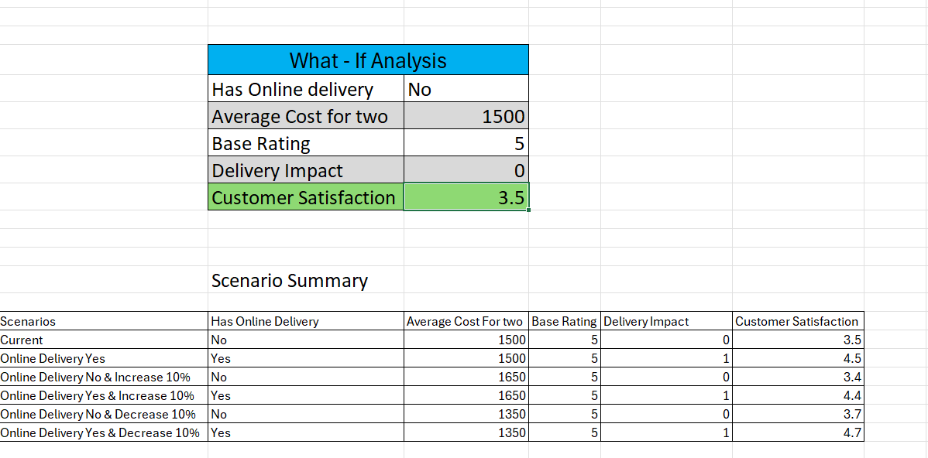

* **From this we could be able to understand which situation leads to the higher customer satisfaction.**

***Task 10: Adding Sparklines for Visualizing Trends***

* **Scenario: Zomato needs to visualize trends in metrics like ratings and votes. Sparklines allow learners to visualize trends without needing full charts.**
* **Steps: Add Sparklines to the dataset to visualize trends in restaurant performance.**
* **Deliverable: Enhanced tables with Sparklines showing trends in customer ratings and votes.**

**Solution:**

* **As the date is not present in data, taking some arbitrary data like 50 restaurants and taking customer rating and votes based on 4 quarters to showcase the trend.**
* **Generated Sparkline for getting the Trends in Rating and Trends in Votes.**
* **From Insert 🡪 Lines Inserted sparkline by selecting the range for Rating and Vote.**

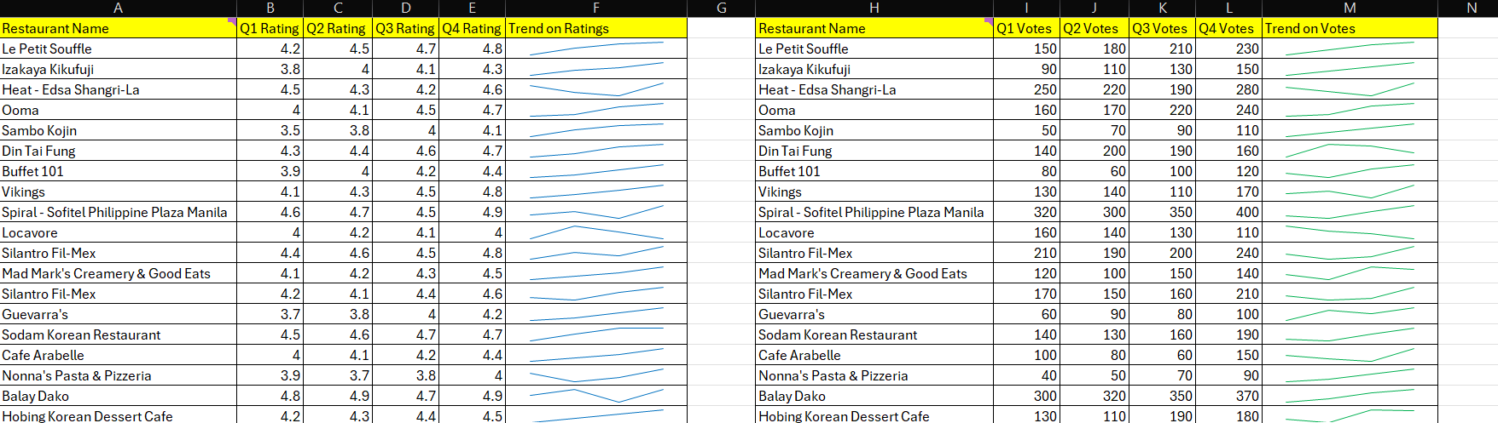

* **The image is showing how the Aggerate rating and Votes are varying over the time for different restaurants.**